MinSPV and MinLPV PRINTING GUIDE
(Minimalist Small Page and Minimalist Large Page Versions)
Remember: Minimalist versions are recommended for those who can manipulate page order, such as those with Adobe Acrobat, OR those willing to print one side of the page only and arrange as they desire (even if it means cutting with scissors!) If this doesn't sound like you, you should purchase the Monthly Versions instead (MonLPV or MonSPV)
Printing MinSPV at Office Depot
SPV means printing 2 pages on the same side of a sheet of paper, reducing the size of the page from 8.5"x11" to 5.5"x8.5". Since Minimalist files contain only one of each unique page, IT'S UP TO YOU to decide the quantities of each page and tell Office Depot that. Let's say you're going to want to print out pages one week at a time... You'll need 1 weekly plan sheet (the left side and the right side) and one Sunday Brain dump, but you'll need 7 day sheets (7 left sides and 7 right sides). Identify that in your email as specifically as you can. "I need 1 each of the following pages: 1,2,3,4,5... and I need 7 each of the following pages: 13,14" The order of the pages doesn't matter as much as you'll arrange them yourself after picking them up. If you're more adept at working with a printer and getting exactly what you want and having things bound and the whole nine yards, by all means! Have at it. This guide is meant for those who have never had, or rarely have, documents printed at Office Depot!
(edit highlighted sections as needed)
If you've never emailed Office Depot before, it's not hard. Call up your local store and ask them to read off to you their email for sending documents for printing. Read it back to them as the email addresses usually contain a lot of numbers. *Note that when I sent my file recently to try this method out, I was sent an "autoreply" message about ordering via website instead. I asked my guy at Office Depot what that was about and he said that it's to avoid them getting stuck with projects that people never come and pick up and pay for. He said when an SPC is mentioned, they usually go through with the project when it's emailed directly to them, and he suggested calling the location to ensure the file arrived and to ask if payment will be needed prior to printing or not. It might, depending on the location and how strictly they follow the rules, be necessary for you to come in to the store and pay before the project is printed. He doubted it though!* When you go into pay and collect your print job, it's a good idea to double check that your MK SPC discount was applied! SOME Office Depot locations require you to show your SPC discount card. If you have never done so, print your discount card from MK Connections on InTouch!
I do NOT recommend having the pages printed front and back (known at Office Depot as 'duplex, top-to-top' ) as you could end up with the left side of a month-calendar spread (Sunday-Tues) on one side of a piece of paper and the right side (Weds-Sat) on the back side of the same sheet. NOT helpful!
You may wish to ask Office Depot to bind the pages in some way, however, I don't recommend that in SPV. There's too high of a likelihood that OD will fold them into the wrong order, and undoing the binding to fix it will be a hassle. Certainly don't do it until you've had the opportunity to review the order of the pages.
In this sample email, it requests having pages cut in half after printing. This is optional, but often people who print their own end up doing a lot of cutting and rearranging, so you might want to have them do this for you. Keep in mind it will probably be an additional fee.
Asking them to hole-punch is another option, however, it's not a simple request. You're going to need to fold the pages in a specific way to maintain the proper order of the pages BEFORE you hole punch them. Perhaps after they are printed, you can fold them as directed in the next section and ask them to hole punch after the fact, being sure to show them in person your binder to be sure it lines up properly.
You might also ask for more than "one set" as each "MonSPV" file is meant to last one month, but perhaps just doing one month first to get a feel for the # of pages and order that you desire is a solid plan. Then once you know it works, you can ask them to print 2 more months to set you up for a quarter of a year.
After you've gotten your pages printed, your next step is folding, and if necessary, cutting. (Unless you choose to have your pages cut in advance) Skip ahead to the part of this guide that says "Folding and Binding".
Hi there! I've got some files I'd like to have printed. I have an SPC Discount that I'd like to use also, the number is 8011 887 9924 . If you have any questions, please contact me by phone or text at 513.304.3680.
All these files can be printed on standard white paper, 8.5"x11" in color ink.
I'd like file named MinSPVPlans to be printed multiple (NOT booklet) 2 x 1 Horizontal, so that each image is approximately 5.5"x8.5" Margins can be a minimum of 1/2".
I'd like 1 of each of the following pages: 1-4.
I'd like 2 each of the following pages: 5-12.
I'd like 14 each of the following pages: 13-14.
Please cut these pages in half down the middle after printing.
I welcome any questions or clarifications on this, and eagerly wait to hear from you when the project is complete. Thanks for all your help!
Erin Mann
--
Printing MinLPV at Office Depot
LPV means printing 1 each image on the full page, so that it fills the majority of an 8.5"x11 sheet of paper. Since Minimalist files contain only one of each unique page, IT'S UP TO YOU to decide the quantities of each page and tell Office Depot that. Let's say you're going to want to print out pages one week at a time. You'll need 1 weekly plan sheet (the left side and the right side) and one Sunday Brain dump, but you'll need 7 day sheets (7 left sides and 7 right sides). Identify that in your email as specifically as you can. "I need 1 each of the following pages: 1,2,3,4,5... and I need 7 each of the following pages: 13,14"
The order of the pages ONLY MATTERS IF you request the printing front-to-back (known in Office Depot Lingo as "duplex, top-to-top". If you do, you'll want to see to it that right-oriented-pages are in an A-B pattern with left-oriented pages, so that it goes "R,L,R,L,R, etc" starting with the Right page. You can tell which pages are oriented which way based on the flower in the upper corner of most of the pages. The flower is on the upper right hand corner of the right-oriented pages and on the upper left of the left-oriented ones (very few exceptions). If you don't follow this rule, it's not the end of the world, your planner should still be usable. Try to make sure "full spread" page sets (like a month calendar at a glance, which shows Sun-Tues on your left hand page, and Weds-Sat on your right hand page) don't end up back to back on the same sheet of paper. If you're NOT printing front-to-back, order doesn't matter at all! You'll arrange them yourself after picking them up. (Note: If you're more adept at working with a printer and getting exactly what you want and having things bound and the whole nine yards, by all means! Have at it. This guide is meant for those who have never had, or rarely have, documents printed at Office Depot!) edit highlighted areas as needed.
Hi there! I've got some files I'd like to have printed. I have an SPC Discount that I'd like to use also, the number is 8011 887 9924 . If you have any questions, please contact me by phone or text at 513.304.3680.
All these files can be printed on standard white paper, 8.5"x11" in color ink.
I'd like file named MinLPVPlans to be printed single-sided. Margins can be a minimum of 1/2".
I'd like 1 of each of the following pages: 1-4.
I'd like 2 each of the following pages: 5-12.
I'd like 14 each of the following pages: 13-14.
I welcome any questions or clarifications on this, and eagerly wait to hear from you when the project is complete. Thanks for all your help!
Erin Mann
If you've never emailed Office Depot before, it's not hard. Call up your local store and ask them to read off to you their email for sending documents for printing. Read it back to them as the email addresses usually contain a lot of numbers. *Note that when I sent my file recently to try this method out, I was sent an "autoreply" message about ordering via website instead. I asked my guy at Office Depot what that was about and he said that it's to avoid them getting stuck with projects that people never come and pick up and pay for. He said when an SPC is mentioned, they usually go through with the project when it's emailed directly to them, and he suggested calling the location to ensure the file arrived and to ask if payment will be needed prior to printing or not. It might, depending on the location and how strictly they follow the rules, be necessary for you to come in to the store and pay before the project is printed. He doubted it though!* When you go into pay and collect your print job, it's a good idea to double check that your MK SPC discount was applied! SOME Office Depot locations require you to show your SPC discount card. If you have never done so, print your discount card from MK Connections on InTouch!
You may wish to ask Office Depot to bind the pages in some way, however, I STRONGLY recommend you verify the proper order of your pages before the binding happens. Go into the store, arrange the pages in the right order, and THEN ask a worker to bind them for you as you've arranged them. This goes for hole-punching as well. Note that binding and hole punching will add to your cost.
I suggest doing only one month at first to see if your layout works. If so, print more (like 2 more months worth if you want a quarter's worth of pages in your planner at a time) as you see fit. You may want to save your email to Office Depot somewhere so that you can repeat the same request when you're ready for refill pages.

Printing at home
MinSPV
Printing at home can cost less or more than Office Depot depending on the price of paper, ink, toner, etc. In order to minimize how much paper you use and also to keep your planner from being to "bulky" printing front-to-back is recommended, but it can get a little hairy when printing 2-to-a-page AND front to back. This is suggested only for those with the technical expertise and adobe software that allows you to affect page order and quantity prior to printing. Otherwise, 2-to-a-page WITHOUT front-to-back is suggested. You'll use more paper, but you'll get total freedom over the order and quantity of each page that you like. Note that printers may vary so choose this option at your own risk and start out a few pages at a time. If you're nervous about doing this, you may want to chose a Monthly version (starts MonSPV), as opposed to a Minimalist version (starts MinSPV)
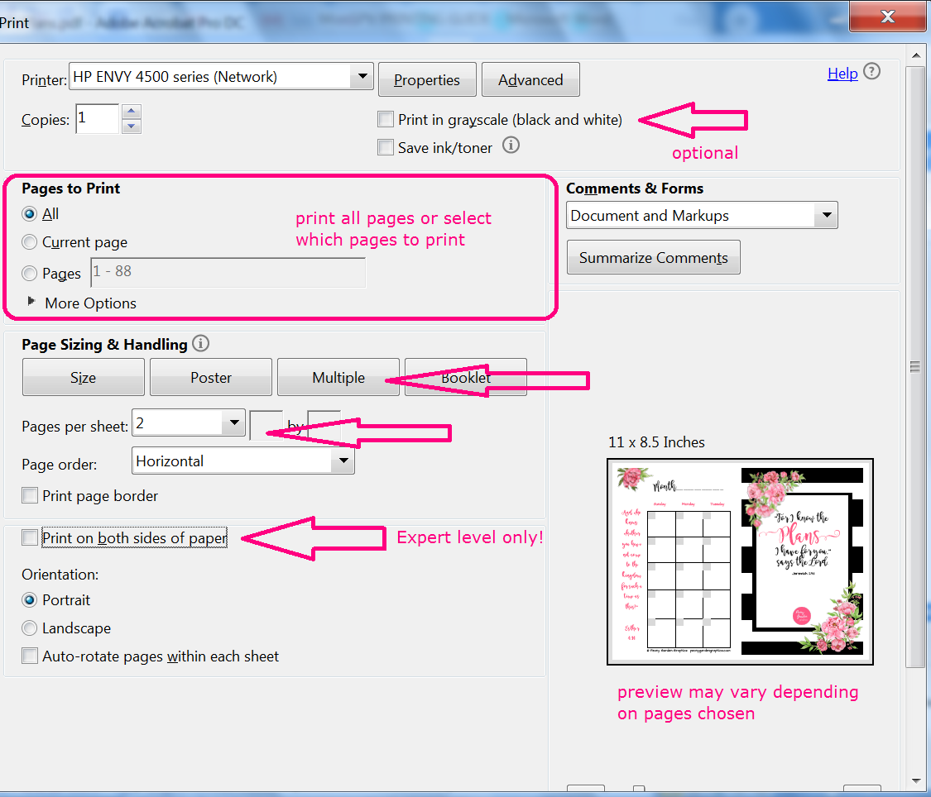
Going from top to bottom, your "print in grayscale" box should be checked IF you choose to print in black/white to save color ink. If you're going to print one of each page, select all pages, but select only specific pages and specify which ones. Under "Page Size & Handling" Select the button that says "Multiple" and where it says "Pages per sheet" select "2". DO NOT ADJUST the option directly below that says "page order" LEAVE THAT BUTTON ALONE. Check the box where it says, "Print on both sides of the paper" ONLY if you feel confident with the order of pages you've purchased! (if you do, you'll want to select the option just below that which says, "flip on the short edge", not shown in this image)
I expect there might be some differences between printers and the software they come with, so in the event that you experience issues, you can email me at peonygardengraphics@gmail.com and put "planner problem" in the subject line. I'll do my best to reach out to you and help resolve the problem if I can. Margins can vary by printer and (watch out if you have an HP OfficeJet 6700!) So if you start printing yourself and have uneven margins or margins that are too small or too large, consider having it printed elsewhere! You can also take these instructions and your file to a library or another printer like FedEx.

Printing MinLPV at home
Printing at home can cost less or more than Office Depot depending on the price of paper, ink, toner, etc. In order to minimize how much paper you use and also to keep your planner from being to "bulky" printing front-to-back is recommended. LPV means you're printing full-size sheets, so as long as you print odd pages on back of even pages, or right-oriented pages on the back of left-oriented pages, printing front-to-back is perfect. Make a list of pages you want to print in the order and quantity of each, and put an "L" next to the left-oriented pages you've chosen (these almost always have a flower in the upper left-hand corner) and make sure they alternate with pages that are right-oriented (flower in the upper right hand corner). Make your first page a Right-oriented page and keep up that R-L-R-L pattern going and it should be perfect. You'll want to pay attention to pages that take up a two-page spread, like your month-at-a-glance, or your weekly plan sheet, or your day-at-a-glance. As long as you hole-punch AFTER you arrange the pages, you'll be fine. Note that printers may vary so choose this option at your own risk and start out a few pages at a time. If you're nervous about doing this, you may want to chose a Monthly version (starts MonLPV), as opposed to a Minimalist version (starts MinLPV)
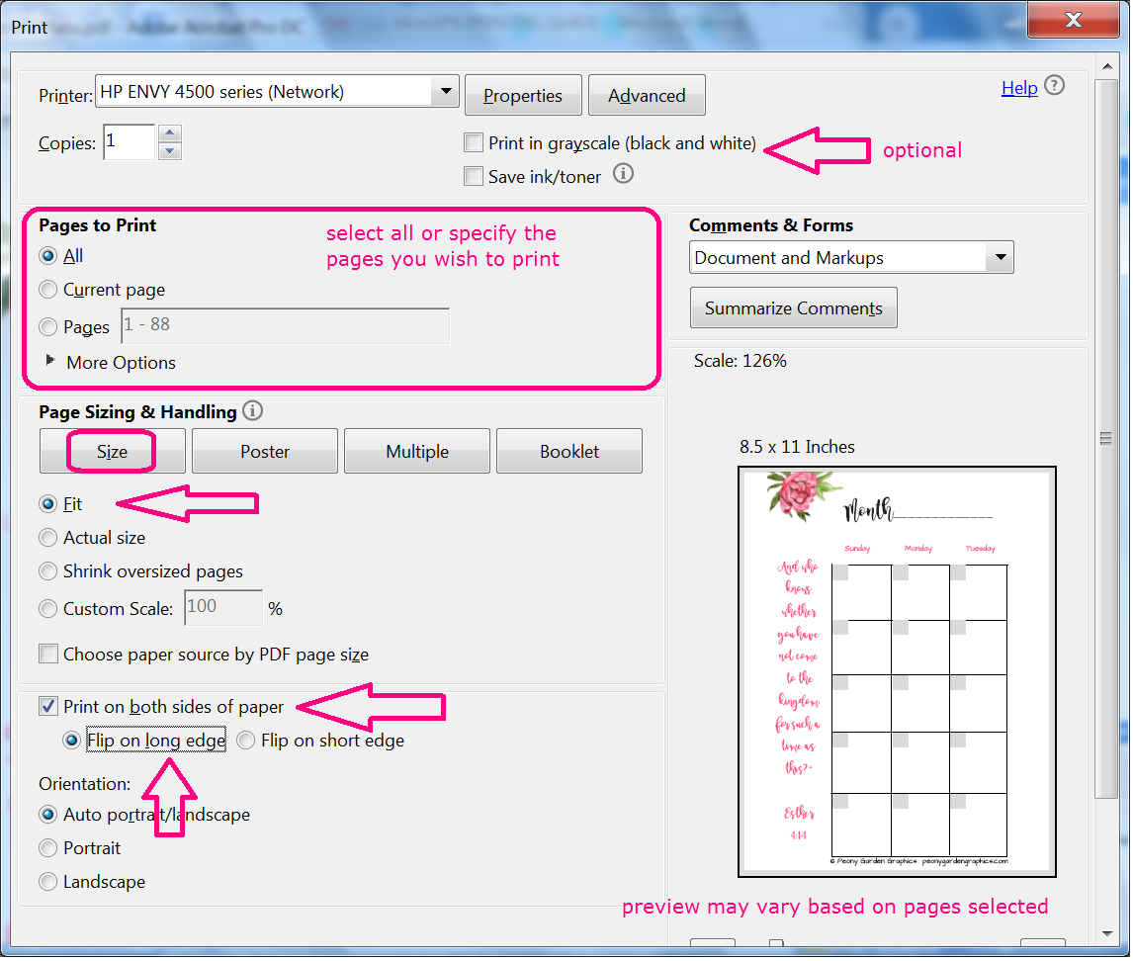
Going from top to bottom, your "print in grayscale" box should be checked IF you choose to print in black/white to save color ink. If you're going to print one of each page, select all pages, OR select only specific pages and specify which ones. Under "Page Size & Handling" Select the button that says "Size" and select "Fit". Check the box where it says, "Print on both sides of the paper" ONLY if you feel confident with the order of pages you've selected! (if you do, you'll want to select the option just below that which says, "flip on the long edge")
I expect there might be some differences between printers and the software they come with, so in the event that you experience issues, you can email me at peonygardengraphics@gmail.com and put "planner problem" in the subject line. I'll do my best to reach out to you and help resolve the problem if I can. Margins can vary by printer and (watch out if you have an HP OfficeJet 6700!) So if you start printing yourself and have uneven margins or margins that are too small or too large, consider having it printed elsewhere! You can also take these instructions and your file to a library or another printer like FedEx.

Folding and Binding your SPV Planner
(unless you had the pages cut in half after printing)
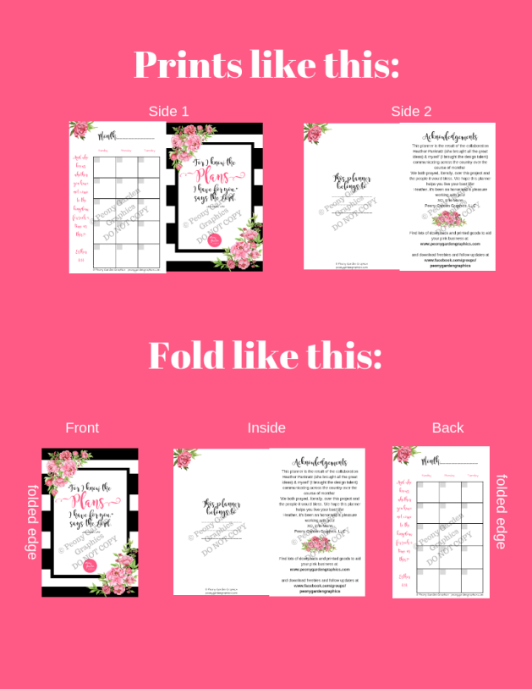
After the printing job is complete, fold EACH page, ONE AT A TIME, in half. This visual should help:
Starting with the cover, the cover should be on the front, the opposite sides become folded inside, and the page that prints to the left of the cover becomes the 4th page, or the back.
Place next to you cover-side down, fourth-page face up. The next sheet of paper, fold the same way, and stack on top of the first set, keeping the folded edges lined up together.
When all the pages have been folded this way and stacked, cover side down, you can bind the pages together. The folded edge is where you'll place hole punches, staples, binder clips, etc.
There should be NO NEED to cut the pages in half using this method.
Using MonSPVPlans as an example, your page order should look like this when folded and bound:
Cover, Belongs to, Acknowledgements, Month Left Side, Month Right Side, To-Do business, To-Do personal, Blotter Page, Sunday Brain Dump, Weekly Plan Left Side, Weekly Plan Right Side, Day Left side, Day Right Side, Day Left side, Day right side, etc
After hole-punching (or whatever method you use to bind the pages together), you may wish to stick it into a mini-binder and add some dividers. I don't get any perks from suggesting the products on the shopping guide on our website, but they seemed like they would work well and be a good starting point for someone who hasn't ever printed their own planner before. Feel free to shop around for what you think will work best for you! See the shopping guide here: www.peonygardengraphics.com/planner-guide

