MonLPV PRINTING GUIDE
(Monthly Large Page Version)
Remember: Monthly versions print what's expected for the average consultant to need in a given month. If you need more of a specific page or pages, see the guides for Minimalist (MinLPV) Printing and follow their instructions for the pages you need.
Printing MonLPV at Office Depot
LPV means printing 1 each image on the full page, so that it fills the majority of an 8.5"x11 sheet of paper. Since Monthly files contain a set quantity of pages of what is expected for a single month of use, and sequenced accordingly.
Sample email to Office Depot (edit highlighted fields as needed)
If you've never emailed Office Depot before, it's not hard. Call up your local store and ask them to read off to you their email for sending documents for printing. Read it back to them as the email addresses usually contain a lot of numbers. *Note that when I sent my file recently to try this method out, I was sent an "autoreply" message about ordering via website instead. I asked my guy at Office Depot what that was about and he said that it's to avoid them getting stuck with projects that people never come and pick up and pay for. He said when an SPC is mentioned, they usually go through with the project when it's emailed directly to them, and he suggested calling the location to ensure the file arrived and to ask if payment will be needed prior to printing or not. It might, depending on the location and how strictly they follow the rules, be necessary for you to come in to the store and pay before the project is printed. He doubted it though!* When you go into pay and collect your print job, it's a good idea to double check that your MK SPC discount was applied! SOME Office Depot locations require you to show your SPC discount card. If you have never done so, print your discount card from MK Connections on InTouch!
Hi there! I've got some files I'd like to have printed. I have an SPC Discount that I'd like to use also, the number is 8011 887 9924 . If you have any questions, please contact me by phone or text at 513.304.3680.
All these files can be printed on standard white paper, 8.5"x11" in color ink.
I'd like file named MonLPVPlans to be printed double-sided. For best margins, please select "size" and "Fit" under the paper sizing and handling settings.
Please print one copy of the entire file in this manner.
I welcome any questions or clarifications on this, and eagerly wait to hear from you when the project is complete. Thanks for all your help!
Erin Mann
You may wish to ask Office Depot to bind the pages in some way, however, I STRONGLY recommend you verify the proper order of your pages before the binding happens. Of all the editions of this planner, the Monthly LPV is the most likely to work well for this! But just to be sure, go into the store, verify they're in the proper order, and THEN ask a worker to bind them for you as you've arranged them. This goes for hole-punching as well. Note that binding and hole punching will add to your cost.
If it works out well (like you hoped!) you may want to save your email to Office Depot somewhere so that you can repeat the same request when you're ready for refill pages.
Printing MonLPV at home
Printing at home can cost less or more than Office Depot depending on the price of paper, ink, toner, etc. In order to minimize how much paper you use and also to keep your planner from being to "bulky" printing front-to-back is recommended. The Monthly version has a given quantity of what is expected a person would use in a given month and sequenced accordingly. If you wish to print more or less of certain pages, you may want to look up the guide for MinLPV printing. Note that printers may vary so choose this option at your own risk and start out a few pages at a time.
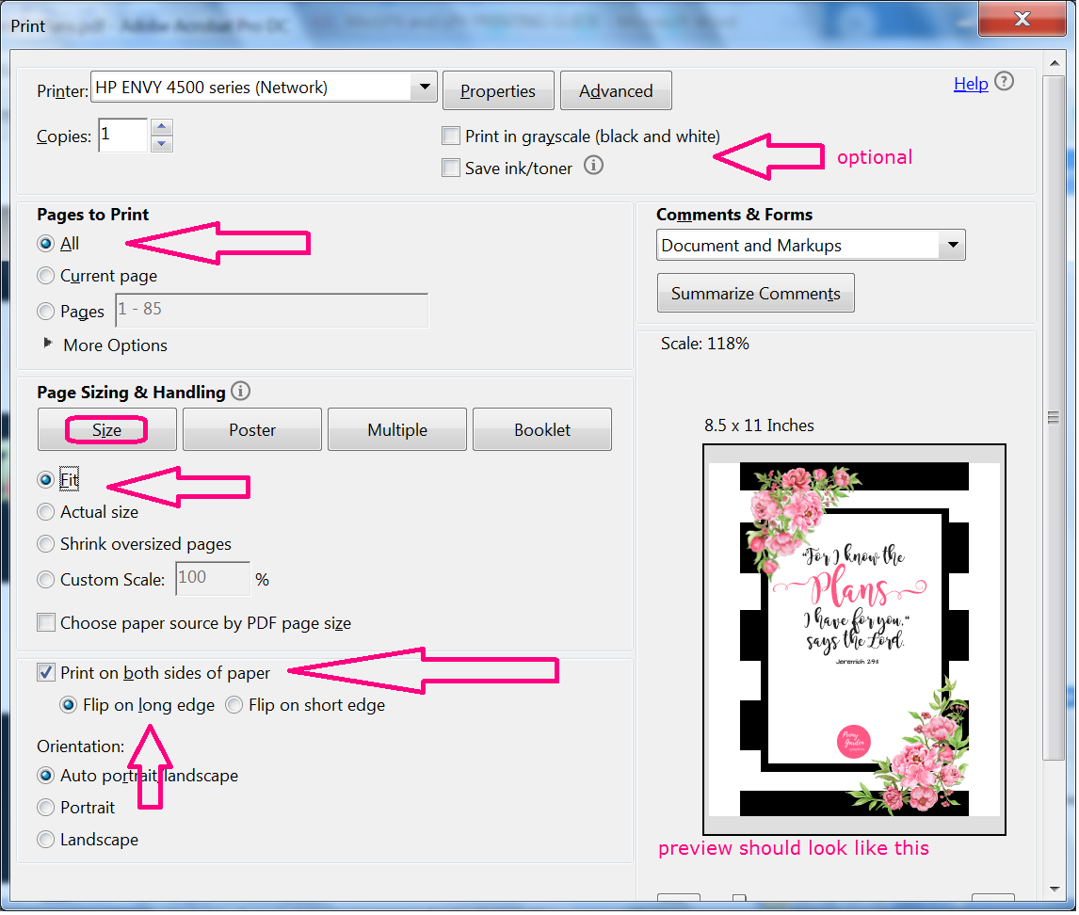
Going from top to bottom, your "print in grayscale" box should be checked IF you choose to print in black/white to save color ink. Select "All" under where it asks which pages to print. Under "Page Size & Handling" Select the button that says "Size" and select "Fit". Check the box where it says, "Print on both sides of the paper" then underneath that select "flip on the long edge"
I expect there might be some differences between printers and the software they come with, so in the event that you experience issues, you can email me at peonygardengraphics@gmail.com and put "planner problem" in the subject line. I'll do my best to reach out to you and help resolve the problem if I can. Margins can vary by printer and (watch out if you have an HP OfficeJet 6700!) So if you start printing yourself and have uneven margins or margins that are too small or too large, consider having it printed elsewhere! You can also take these instructions and your file to a library or another printer like FedEx.
After hole-punching (or whatever method you use to bind the pages together), you may wish to stick it into a binder and add some dividers. I don't get any perks from suggesting the products on the shopping guide on our website, but they seemed like they would work well and be a good starting point for someone who hasn't ever printed their own planner before. Feel free to shop around for what you think will work best for you! See the shopping guide here: www.peonygardengraphics.com/planner-guide

