MonSPV PRINTING GUIDE
(Month Small Page Version)

Sending an email to Office Depot (edit highlighted sections as needed)
If you've never emailed Office Depot before, it's not hard. Call up your local store and ask them to read off to you their email for sending documents for printing. Read it back to them as the email addresses usually contain a lot of numbers. *Note that when I sent my file recently to try this method out, I was sent an "autoreply" message about ordering via website instead. I asked my guy at Office Depot what that was about and he said that it's to avoid them getting stuck with projects that people never come and pick up and pay for. He said when an SPC is mentioned, they usually go through with the project when it's emailed directly to them, and he suggested calling the location to ensure the file arrived and to ask if payment will be needed prior to printing or not. It might, depending on the location and how strictly they follow the rules, be necessary for you to come in to the store and pay before the project is printed. He doubted it though!* When you go into pay and collect your print job, it's a good idea to double check that your MK SPC discount was applied! SOME Office Depot locations require you to show your SPC discount card. If you have never done so, print your discount card from MK Connections on InTouch!
You may wish to ask Office Depot to bind the pages in some way, however, I don't recommend that in SPV. There's too high of a likelihood that OD will fold them into the wrong order, and undoing the binding to fix it will be a hassle.
Asking them to hole-punch is another option, however, it's not a simple request. You're going to need to fold the pages in a specific way to maintain the proper order of the pages BEFORE you hole punch them. Perhaps after they are printed, you can fold them as directed in the next section and ask them to hole punch after the fact, being sure to show them in person your binder to be sure it lines up properly.
You might also ask for more than "one set" as each "MonSPV" file is meant to last one month. So perhaps you'll want them to print 3 months at a time to last you one quarter of a year.
After you've gotten your pages printed, your next step is folding. Skip ahead to page 3.
Hi there! I've got some files I'd like to have printed. I have an SPC Discount that I'd like to use also, the number is 8011 887 9924 . If you have any questions, please contact me by phone or text at 513.304.3680.
All these files can be printed on standard white paper, 8.5"x11" in color ink.
I'd like file named MonSPVPlans to be printed as follows: In multiple format (NOT booklet!) horizontal, 2 x 1 pages per sheet, and Duplex oriented top-to-top.
(In other words, 2 to a page, front and back, flipped on the short edge (so that the top of each page lines up from front to back). The order of the pages should print out page 1 & 2 on the front of the first page, with page 3 & 4 on the other side, so that 4 is on the back of page 1, and page 3 is on the back of page 2.)
I'd like one set of this file printed. I do NOT require pages to be cut in half. Margins can be a minimum of 1/2"
I welcome any questions or clarifications on this, and eagerly wait to hear from you when the project is complete. Thanks for all your help!
Erin Mann
Printing at home
Printing at home can cost less or more than Office Depot depending on the price of paper, ink, toner, etc. In order to minimize how much paper you use and also to keep your planner from being to "bulky" printing front-to-back is recommended, but it can get a little hairy when printing 2-to-a-page AND front to back. Hopefully we've tested this process enough to give this guide in confidence. (Note that printers may vary so choose this option at your own risk and start out a few pages at a time)
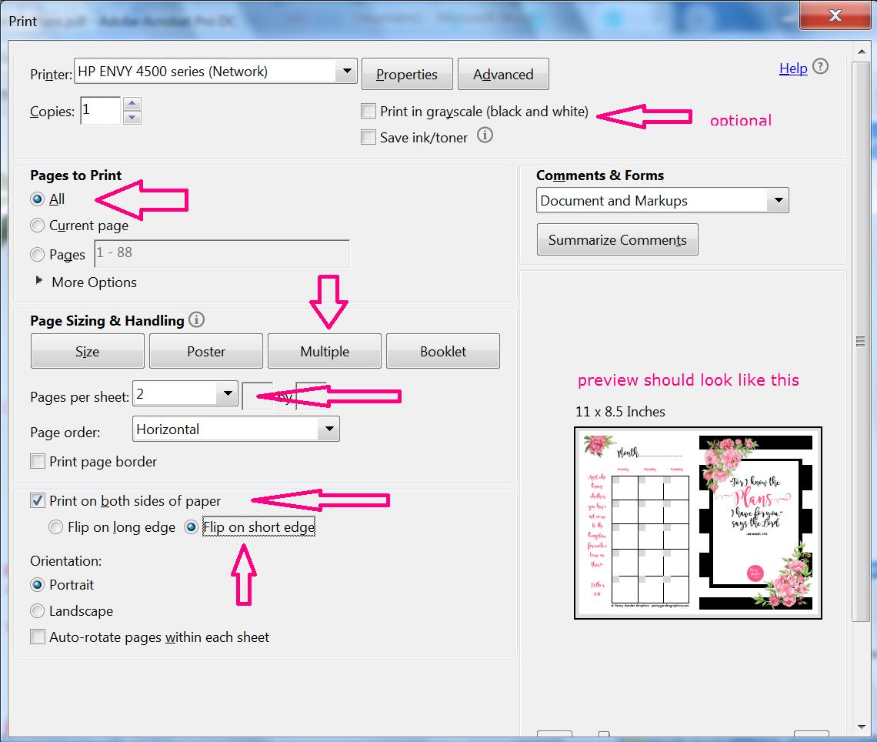
Going from top to bottom, your "print in grayscale" box should be checked IF you choose to print in black/white to save color ink. Make sure you've selected all pages to print. Select the button that says "Multiple" and where it says "Pages per sheet" select "2". DO NOT ADJUST the option directly below that says "page order" LEAVE THAT BUTTON ALONE. Check the box where it says, "Print on both sides of the paper" then select the option just below that which says, "flip on the short edge"
I expect there might be some differences between printers and the software they come with, so in the event that you experience issues, you can email me at peonygardengraphics@gmail.com and put "planner problem" in the subject line. I'll do my best to reach out to you and help resolve the problem if I can. Margins can vary by printer and (watch out if you have an HP OfficeJet 6700!) So if you start printing yourself and have uneven margins or margins that are too small or too large, consider having it printed elsewhere! You can also take these instructions and your file to a library or another printer like FedEx.
Folding and Binding

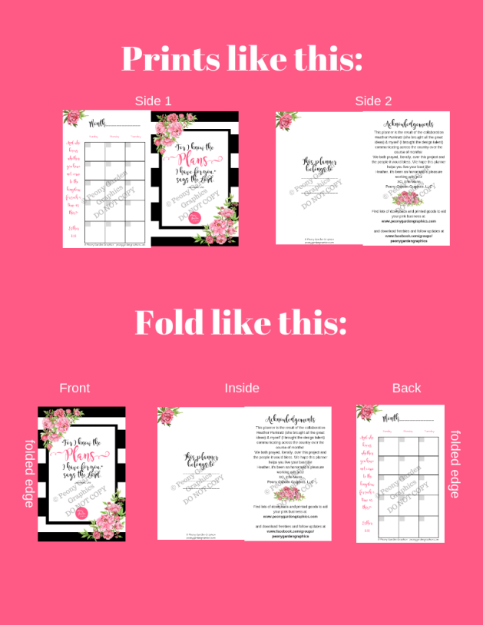
After the printing job is complete, fold EACH page, ONE AT A TIME, in half. This visual should help:
Starting with the cover, the cover should be on the front, the opposite sides become folded inside, and the page that prints to the left of the cover becomes the 4th page, or the back.
Place next to you cover-side down, fourth-page face up. The next sheet of paper, fold the same way, and stack on top of the first set, keeping the folded edges lined up together.
When all the pages have been folded this way and stacked, cover side down, you can bind the pages together. The folded edge is where you'll place hole punches, staples, binder clips, etc.
There should be NO NEED to cut the pages in half using this method.
Using MonSPVPlans as an example, your page order should look like this when folded and bound:
Cover, Belongs to, Acknowledgements, Month Left Side, Month Right Side, To-Do business, To-Do personal, Blotter Page, Sunday Brain Dump, Weekly Plan Left Side, Weekly Plan Right Side, Day Left side, Day Right Side, Day Left side, Day right side, etc
After hole-punching (or whatever method you use to bind the pages together), you may wish to stick it into a mini-binder and add some dividers. I don't get any perks from suggesting the products on the shopping guide on our website, but they seemed like they would work well and be a good starting point for someone who hasn't ever printed their own planner before. Feel free to shop around for what you think will work best for you! See the shopping guide here: www.peonygardengraphics.com/planner-guide

